EMERGENCY PREPARATION CHECKLIST
SHELTER INFORMATION:
- Website to find current shelters open: http://hillsboroughcounty.org/en/residents/public-safety/emergency-management/stay-safe
- Always check the shelter is for high intensity storms and don’t go unless local officials have announced openings
- General populations shelters do NOT provide food, water, cots or blankets
- Bring 1 gallon of water per person per day, non-perishable and easy to prepare food, bedding, pillows and blankets, medications, medical items, hearing aids, glasses, sanitation and personal hygiene items and baby supplies.
PET-FRIENDLY SHELTERS:
- Proof of current rabies vaccination and license for dogs/cats
- Pet must be on a leash or in a carrier
- A crate large enough for pet to stand up and turn around
- Cats need crate large enough to contain litter/food/water
- Crate, food, water, litter, treats, cleaning supplies and meds
- You are responsible for the care of your pet while in the shelter
- Cohabitation of pets and owners is not permitted
- If you are unable to meet these requirements; make other arrangements to shelter your pet
SPECIAL NEEDS SHELTERS:
- For residents needing more skilled care than in a general shelter; including assistance from medical professionals, but not requiring an acute care facility such as a hospital
- Pre-register for the program, call The Special Needs Client Registration Line at 813-307-8063 and leave a voicemail or Hillsborough Info Line at 813-272-5900

ITEMS TO HAVE ON HAND SURVIVAL KIT:
- Water- 1 gallon per person a day for 3 days min.
- Survival food- freezable dried food and ready to eat meals, nuts, peanut butter crackers, protein bars, canned goods, dried fruits and vegetables, any item that does not need refrigeration or cooking. Non-perishable food items that don’t weigh a lot. Cans are heavy!
- Have on hand 2 weeks’ food and water in your home stored in plastic bins. (These can be transported if needed).
- Infant formula, bottles and diapers
- Paper plates, plastic utensils, paper towels
- Sanitation, hygiene items, feminine supplies- baby wipes, trash bags, general products
- Emergency blanket-waterproof, windproof, effectively reflects body heat to keep you warm.
- Tent, Extra clothing, Duct tape, Bug spray, Pen and notebook
- Flashlights with extra batteries, candles and matches
- Portable radio or tv- battery operated with extra batteries. Use to gauge situation in other areas, and be able to talk to others if you’re stuck somewhere
- Cell phone and charger with pre-charged back up charger
- Cash and coins- you never know when you’ll need money, it is best to keep a nice chunk of change in your natural disaster kit, if banks are not working for a while: $100-1,000 depending on needs/size of family.
- Gas- Extra for Generator and Cars
- Shovel, pocket knife, pliers, multi-tool
- A whistle to signal for help
- Activities for children; books, games, card decks, puzzles or coloring for kids to do by daylight/lantern light!
- First aid kit and instructions, Prescription medication
- Fire extinguisher
- Household chlorine bleach and medicine dropper 8 drops to 1 gallon to disinfect water
- Pet needs

TIPS/NOTES:
What can you fit in your car if you had to evacuate?
Having an entire room of food/supplies would not work!
Able to stay At home:
- Have all laundry/dishes done ahead of time as people will need clean clothes, and sanitary conditions.
- Water filters on kitchen faucets.
- Trim your trees in the spring! Move flower pots and lawn furniture indoors!
- Led batt. operated lanterns instead of a bunch of small flashlights!
Do not open fridge or freezer doors: will preserve food.
- 4 hours in unopened fridge.
- 24 hours in unopened 1/2 full freezer, 48 for full.
- Have a cooler to keep perishable items in like breast milk, medicines, ect. so you do not have to open the fridge!
- Keep 2 weeks’ supply on hand at all times for the number of persons in your household. Why? Even if the actual event did not take place in our area, here is what does take place!
1. We are in the zone that evacuees move to, so they buy up supplies!
2. When power is out the stores are not open or restaurants.
3. Can take a week for power to return.
4. Can take an extra week for stores to restock items as they must be flown and trucked in, this takes time when trees/power is down.
5. Media creates hysteria over gas, water, toilet paper, people hoard!
- Prior Proper Planning!

CRITICAL PERSONAL DOCUMENTS
(HARD AND DIGITAL COPY)
- Copy of home, auto, health insurance
- Medical Records
- Insurance cards for each family member
- Wills, trust, deeds, birth certificates, social security cards,
- Bank account’s numbers
- License, ID cards, passports; extra copies, marriage license
- Personal and family records, Family emergency contacts
- Computer hard drive back up
BUILD AN INVENTORY:
- Take pictures of rooms and important individual items. Label pictures with a description, where you bought and make, model and serial number
- Create electronic file. Use computer to make inventory list. Personal finance software packages often include homeowner’s room-by- room inventory program.
- Store inventory, with receipts, of paper and electronic photos, lists, and files in a safety deposit box or at a friend’s colleagues home.
- Expensive valuable items like jewelry, art, collectibles may have increased in value since received. Check with your insurance agent tomato sure you have adequate insurance for these items. They may need to be insured separately.

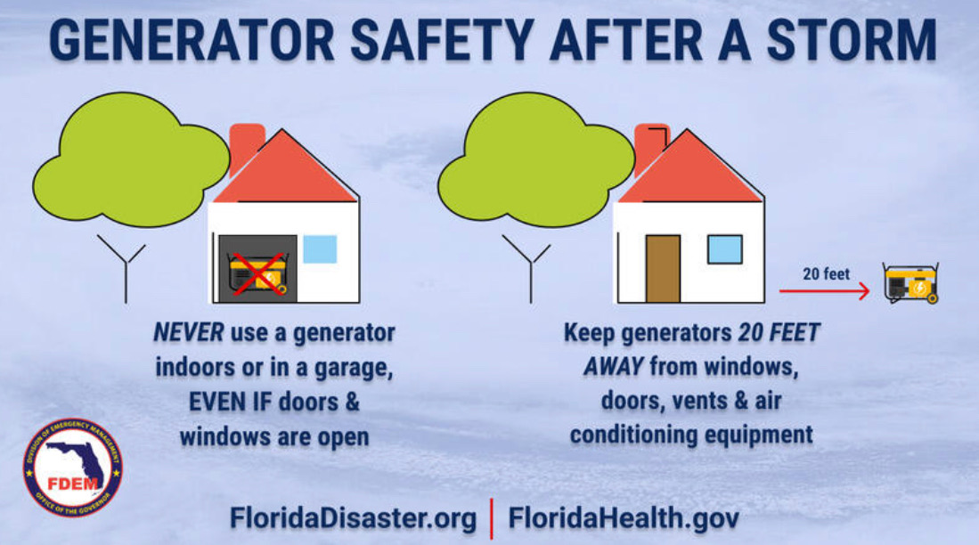
HAVE A PLAN:
- This is spelled out and distributed to everyone in the family well in advanced.
- Designate a place for all family members to meet. Make sure the meeting place is outside the impacted area.
- Keep your fuel tank filled in your car. Determine how much fuel you willed to reach your meeting place.
- Identify a contact person outside the affected area. Give their contact info to everyone in the family so they can serve as a point of contact if you get separated.

SUGGESTED HURRICANE SUPPLY LIST
To prepare for the unknown, each home should have a 72-hour Disaster Survival Kit. You will need to pack some essential items to help you and your family survive, whether you stay at home or leave it during a disaster. Ensure at least three days (72 hours) supply for each person. Do not forget pets where applicable! The following is a minimum suggested list of Survival Kit supplies:

DRINKING WATER:
- One gallon per person/per day in unbreakable containers, avoid using containers that will decompose or breakable such as milk cartons or glass bottles. A normally active person needs to drink at least two quarts of water each day. Hot environments and intense physical activity can double that amount. Children, nursing mothers, and ill people will need more.
- Don't forget to add additional water for mixing formula if you have children and for your pets. Rotate the drinking water each year.
- Food preparation and sanitation require another two quarts (minimum) per person daily.
- Purchased bottled water that has been sealed is best for storage. It meets FDA guidelines for food and is not as vulnerable to temperature changes as unsealed water
- Tip: Purchase water this year and use it for drinking next year. This allows for rotation on an annual basis and keeps the water fresh.
Yes, water can go bad!

WATER FOR SANITATION USE:
- Store extra containers of water to be used for flushing toilets, cleaning, and bathing.
- Purchase water purification tablets (Halazone) to be used if you still have running water but are told to boil water before using it. This allows you to fill the bathtub and other containers without purchasing expensive drinking water.
- Tip: Keep plastic containers (milk jugs and other containers) and fill them with water when a storm threatens. You can put these items in the freezer to keep food cold longer in the event that the electricity goes out.

NON-PERISHABLE FOOD
- Maintain at least 3-7 days of food for each member of the family.
- Small, preferably single serving cans (should not require cooking or refrigeration). Dried fruit, peanut butter and jelly, coffee, tea, soft drinks and pet foods.
- Ready-to-eat canned meats, fruits and vegetables.
- Canned juices, milk, soup (if powdered, store extra water).
- Staples - sugar, salt, pepper in water proof containers.
- High energy foods like crackers, granola bars, trail mix.
- Raw vegetables that do not need refrigeration.
- Fresh bread.
- Comfort/stress foods - cookies, hard candy, sweetened cereals, lollipops, instant coffee, tea bags.
- Sterno for cooking.
- Vitamins
- Food for infants
- Paper cups, plates, and plastic utensils
- Non-electric can opener
- Aluminum foil
- Plastic storage containers
- Lots of ice (you can freeze your water supply)
- Pedialyte (to restore hydration if needed)
- Tip: Purchase only items that you like to eat and would eat even without a storm. Rotate these items by using them Dec-May each year and purchasing new items Jan-May. This allows you to reduce the cost of buying items for a hurricane kit at one time and keeps the items fresh. Yes, even canned goods have a shelf life!

GENERATOR TIPS:
- Make sure you can move/lift, gas cans full, can you lift the full gas cans?
- Ext. cord that keeps your generator away from house?
Is generator secure from theft/weather?
A generator is not ideal for everyone!

FIRST AID KIT:
- Assemble a first aid kit for your home and one for each car.
- Adhesive bandages various sizes -- Sterile gauze pads (various sizes)
- Germicidal hand wipes or waterless alcohol-based hand sanitizer
- Non-latex gloves -- Adhesive tape -- Anti-bacterial ointment -- Antiseptic spray
- Cold packs (non refrigerated type) - Scissors - Tweezers -- Rubbing alcohol
- CPR breathing barrier, such as a face shield -- Thermometer, Safety pins.

TOOLS AND SUPPLIES:
- Masking and/or duct tape
- Nails and screws, screwdriver and hammer
- Bucket/mop, broom
- Pliers/wrenches
- Shovel, rake
- Tarps to cover roof
- Utility knife, razor knife, hand saw
- Signal flare, Compass
- (2-3) Flashlights with extra batteries and bulbs
- Fire extinguisher
- Rope caulk
- Plywood
- Portable a/c unit
- Battery operated radio with extra batteries
- Matches in a waterproof container
- Portable generator
- All-purpose cleaner, bleach
- Plastic sheet/drop cloth
- BBQ grill
- Bug repellant, sun screen
- Shut-off wrench to run off household
- Wheelbarrow
- Sandbags
- Extra filled propane tanks, Gas
- Whistle
- Water

NON-PRESCRIPTION DRUGS:
- Aspirin or non-aspirin pain reliever, Benadryl, peroxide
- Anti-diarrhea medication, Antacid (for stomach upset)
- Syrup of Ipecac (use to induce vomiting if advised by the
- (Poison Control Center) number (800) 222-1222
- Laxative
- Activated charcoal (use if advised by the Poison Control Center)

PRESCRIPTION DRUGS:
- Heart and high blood pressure medication
- Insulin (enough for a 30-day supply)
- Hearing Aid and extra batteries
- Prescription drugs
- Denture needs
- Contact lenses and supplies
- Extra eye glasses
- Tip: If your insurance will allow, get a 90-day supply of prescriptions and have at least a 30-day supply. Don't wait until a couple of days before a storm to go to the pharmacy for refills you may not get your prescription refilled; the lines are long and they run out of supplies very quickly.

BABY NEEDS:
- Special foods (enough for several days)
- Formula (enough for several days)
- Extra diapers
- Medicines (get a copy of prescription)
- Blankets
- Diaper Rash Ointment
- Baby Wipes
- Powder
- Bottles
- Pacifier
- Favorite toy/blanket
- Medicine dropper
- Diaper-rash ointment

SANITATION:
- Toilet paper, towelettes, soap, baby wipes, liquid hand sanitizer
- Feminine supplies
- Personal hygiene items (toothpaste, deodorant, shampoo etc.)
- Plastic garage bags, ties) for personal sanitation uses)
- Plastic bucket with tight lid
- Household Chlorine bleach, disinfectant
- Plenty of absorbent towel

CLOTHING AND BEDDING:
- Include at least one complete change of clothing and footwear per person.
- Sturdy shoes or work boots
- Towels
- Rain gear
- Blankets or sleeping bags
- Pillows
- Hat and gloves
- Sunglasses
- Tent
- Lawn chairs

ENTERTAINMENT:
- Games
- Books
- Cards
- Extra batteries for games
- Coloring books, crayons

MISCELLANEOUS:
- Wind-up or battery-operated clock
- Paper, pencil
- Needles, thread
- Camping utensils
- Map of the area (for locating shelters) and returning to the area.
- Cash or traveler's checks
- Tip: Have enough cash to sustain you through a 2-week period. Without electricity, most businesses (if open) will not accept credit cards and may not accept traveler's checks.
- Emergency preparedness manual
- Citronella candles

